**Note**: When using *Labelme* for annotating chicken head images, ensure that the rectangular boxes are uniformly drawn from the upper left corner to the lower right corner to complete the annotations. The data annotation process is as follows:

1. On your computer keyboard, press and hold the **Win** and **R** keys simultaneously to open the Windows run command box, then type **cmd** to open the command line window.

2. Enter the command "pip install labelme" and press **Enter** on the keyboard to install *Labelme* (if this is not the first time, you can skip this step).

3. After installation is complete, type "labelme" and press **Enter** on the keyboard to open the *Labelme* software, as shown in the figure below.

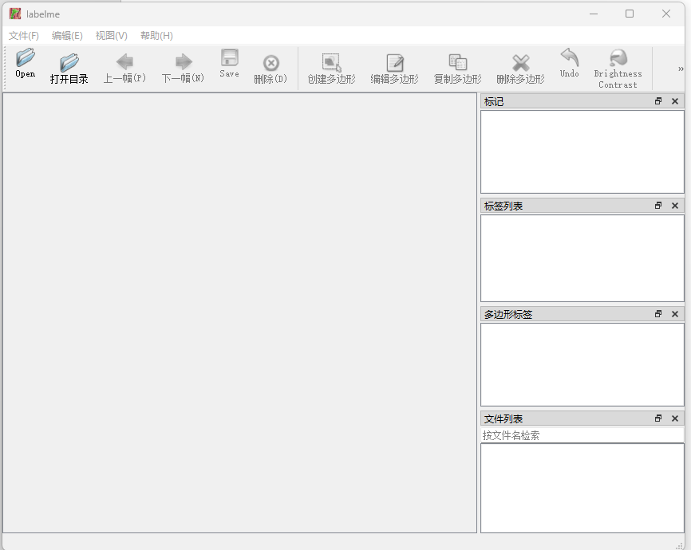

4. Click the **"Open Directory"** button on the *Labelme* software interface to open the folder where the raw dataset images are stored on your computer (the folder path should be in English), as shown in the figure below.

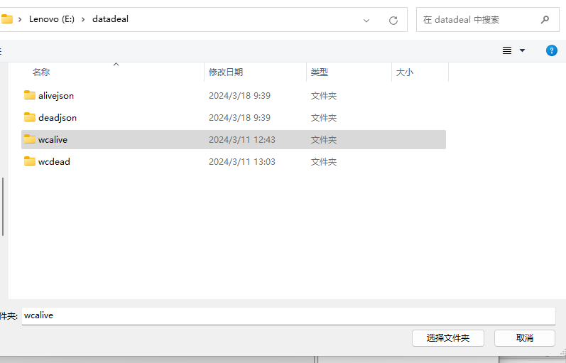

5. Click the **"File"** button on the *Labelme* software interface, then click the **"Auto Save"** button. After that, click the **"Change Output Path"** button to specify the output path for storing the annotated labels, which should be an English path, as shown in the figure below.

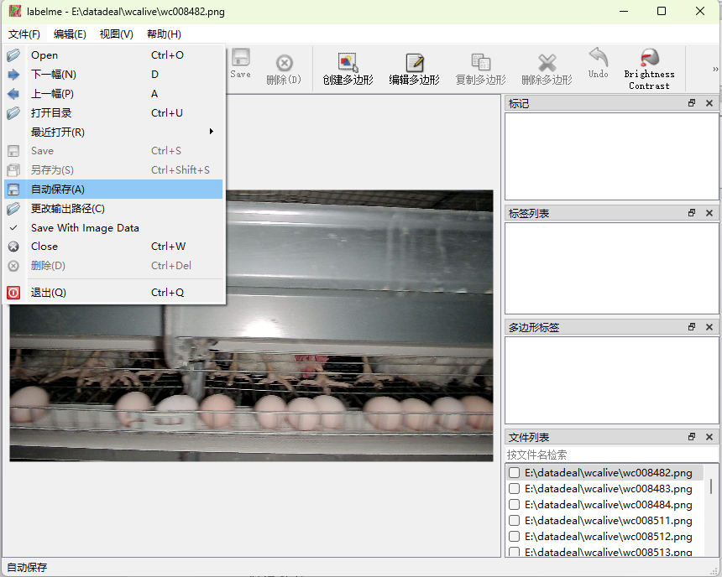

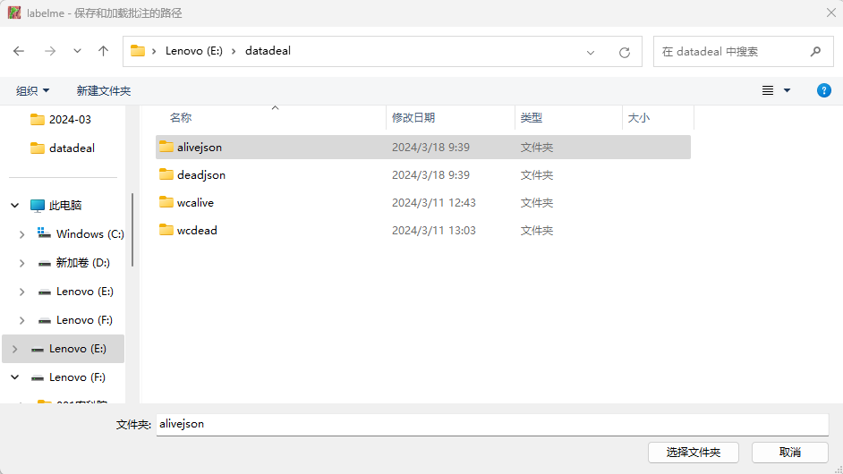

6. Click the **"Edit"** button on the *Labelme* software interface, then click the **"Create Rectangle"** button, as shown in the figure below.

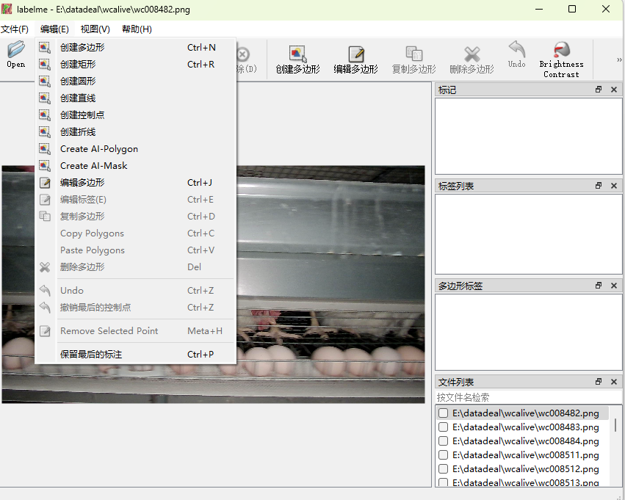

7. After activating the crosshair for data annotation, press the left mouse button to mark the top-left coordinate of the chicken head. Then move the mouse to the bottom-right corner of the chicken head and press the left mouse button again to complete the selection of the chicken head target. Next, in the pop-up *Labelme* window, input the label name for the annotated chicken head object, and click the **"OK"** button to complete the data annotation, as shown in the figure below.

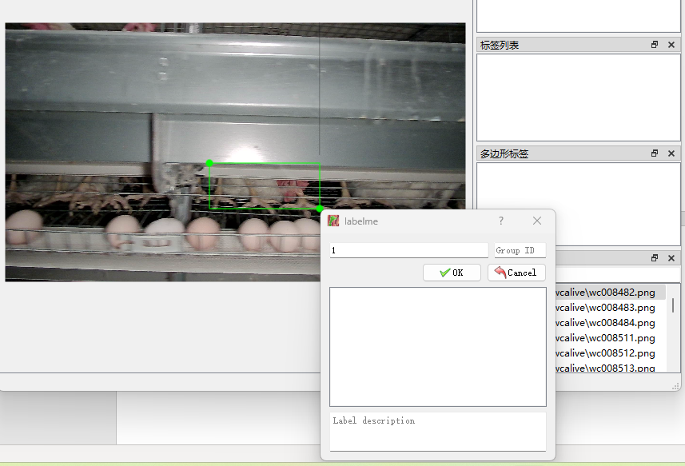

8. After annotating all the chicken head targets in one image according to Step 7, press the **"D"** key on the keyboard to switch to the next chicken image. If you want to switch to the previous image, press the **"A"** key on the keyboard.

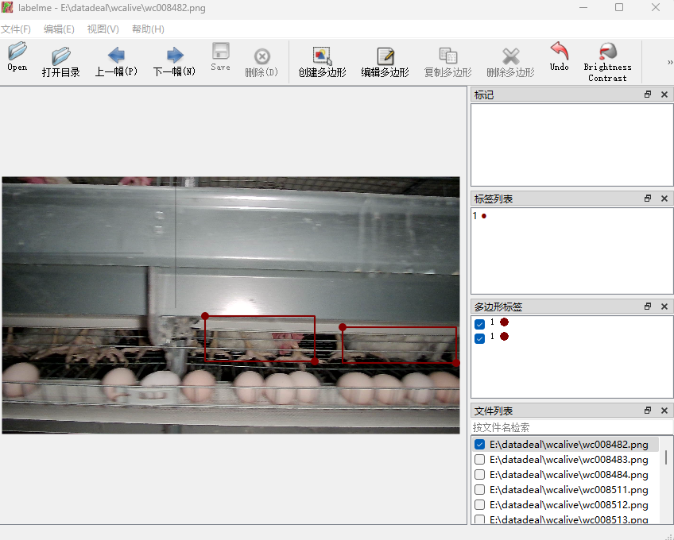

9. After completing the annotation for all the dataset images in the folder selected in Step 4, click the **Close** button on the *Labelme* software interface. If the annotated images are not saved automatically, a save prompt will appear. Click **"Save"** to confirm saving the chicken head labels.

10. Compare the number of files in the folder selected in Step 4 with the folder selected in Step 5 to ensure the file count matches.

11. Data annotation is complete.